Handheld Devices for Control
Brad A. Myers*, Jeffrey Nichols*, Jacob O. Wobbrock*, Kevin Litwack*, Michael Higgins†, Joe Hughes†,
Thomas K. Harris*, Roni Rosenfeld*, Mathilde Pignol*
*Human-Computer Interaction Institute  Carnegie Mellon University  School of Computer Science  Pittsburgh, PA 15213 USA  bam@cs.cmu.edu  http://www.cs.cmu.edu/~bam | †MAYA Design, Inc.  Suite 702  2100 Wharton Street  Pittsburgh, PA 15203  {higgins, hughes}@maya.com
Abstract. With today’s and tomorrow’s wireless technologies, such as IEEE 802.11, BlueTooth, RF-Lite, and G3, handheld devices will frequently be in close, interactive communication. Many environments, including offices, meeting rooms, automobiles and classrooms, already contain many computers and computerized appliances, and the smart homes of the future will have ubiquitous embedded computation. When the user enters one of these environments carrying a handheld device, how will that device interact with the immediate environment? We are exploring, as part of the Pebbles research project, the many ways that handheld devices such as PalmOS Organizers, PocketPC / Windows CE devices and smart cell phones, can serve as useful adjuncts to the “fixed” computers and computerized appliances in the user’s vicinity. This brings up many interesting research questions, such as: How can the handheld device improve the user interfaces of everything else in the user’s environment, rather than being just be another complex gadget that must be learned? What is the best way to provide a user interface that spans multiple devices that are in use at the same time? How will users and systems decide which functions should be presented and in what manner on what device? How can the user’s handheld device be effectively used as a “Personal Universal Controller” to provide an easy-to-use and familiar interface to all of the complex appliances available to a user? How can communicating handheld devices enhance the effectiveness of meetings and classroom lectures? We present some preliminary observations on these issues, and discuss some of the systems that we have built to investigate them.
For more information, see http://www.pebbles.hcii.cmu.edu/.

Extended Abstract
It has always been part of the vision of handheld and mobile devices that they would be in continuous communication. For example, the ParcTab small handheld devices [Want 1995], which were part of the original ubiquitous computing research project at Xerox PARC, were continuously communicating with the network using an infrared network. Mobile phones are popular because they allow people to stay in constant contact with others. However, the previous two or three generations of commercial handheld personal digital assistants (PDAs), such as the Apple Newton and the Palm Pilot, did not provide this capability, and only rarely communicated with other devices. For example, the Palm Pilot is designed to “HotSync” with a PC about once a day to update the information.
With the growing availability and popularity of new wireless technologies, such as IEEE 802.11, BlueTooth [Haartsen 1998], RF-Lite [Zigbee Alliance 2002], always-on two-way pagers, and email devices such as the Blackberry RIM, continuous communication is returning to commercial handhelds. What will be the impact of this on the user interfaces?
Another important observation is that most of people’s time is spent in environments where there are already many computerized devices. Most offices have one or more desktop or laptop computers and displays. Many meeting rooms and classrooms have permanent or portable data projectors and PCs. Automobiles contain dozens of computers, and dashboards are likely to include LCD panels, sometimes replacing the conventional gauges. The more expensive airplane passenger seats provide individual LCD display screens for watching movies. Homes have televisions, PCs and many appliances with display screens and push buttons.
Our focus in the Pebbles project [Myers 2001] is to look at how handheld devices will interoperate with each other and with other computerized devices in the users’ environment. This brings up a number of interesting new research issues. For example:
- How can the user interface be most effectively spread across all the devices that are available to the user? If there is a large screen nearby, there may be no need for all the information to be crammed into the tiny screen of a PDA. When a PDA is near a PC, the PC’s keyboard will often be an easier way to enter text than the PDA’s input methods, but on the other hand, the PDA’s stylus and touch screen may be a more convenient input device for drawing or selecting options for the PC than using a mouse. We call these situations multi-machine user interfaces since a person may be using multiple machines to complete the same task.
- Can communicating mobile devices enhance the effectiveness of meetings and classroom lectures? People at their seat may be able to use their PDAs to interact with the content displayed on the wall without having to physically take the keyboard and mouse away from the speaker. If there are multiple people in front of a large shared display, then mobile devices may be used for private investigation of the public information without disrupting the public displays. In classrooms, students may be able to answer questions using handhelds with the results immediately graded and summarized on the public display.
- Can the user’s mobile device be used to provide an easy-to-use and familiar interface to all of the complex appliances available to the user? If the user has a mobile device with a high-quality screen and a good input method, why would a low-quality remote control be used for an appliance? Our preliminary studies suggest that users can operate a remote control on a PDA in one-half the time with one-half the errors as the manufacturers’ original appliance interfaces [Nichols 2001]. Furthermore, allowing the remote to engage in a two-way communication with the appliances enables the creation of high-quality specialized devices that provide access to the disabled. For example, the INCITS V2 standardization effort [V2 Working Group 2002] is creating the Alternative Interface Access Protocol that will let people with visual difficulties use mobile Braille and speech devices to control household appliances.

My presentation will discuss these issues and demonstrate the programs we have created to date. This includes automatic generation of graphical interfaces and speech interfaces to serve as remote controls for various appliances [Myers 2002a] [Nichols 2002b] [Nichols 2002a], using the handheld as a remote control for PowerPoint and other PC applications [Myers 2000], and using a handheld to help people with motor impairments access their computers [Myers 2002b]. Pictures of some of these applications are shown in Figures 1 and 2.

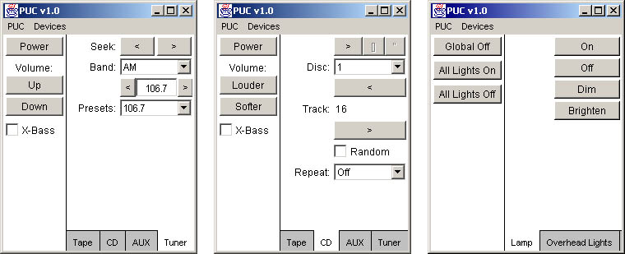
(a) (b) (c)
Figure 1. Automatically generated interfaces for an Audiophase shelf stereo with its CD (a) and tuner (b); and for a system to control room lights (c).
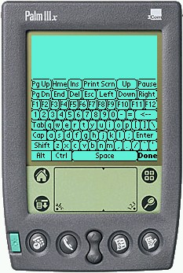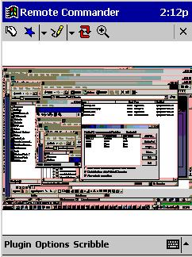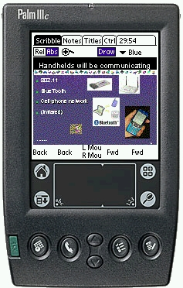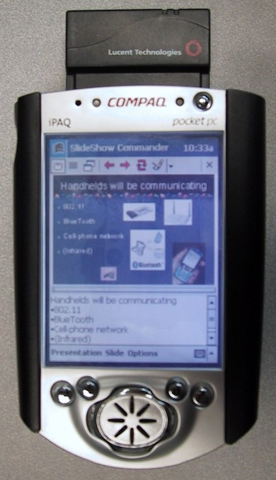
(a) (b) (c) (d)
Figure 2. Palm (a) and PocketPC (b) versions of “Remote Commander” that lets the handheld control the PC. Screens from “SlideShow Commander” for (c) Palm and (d) PocketPC that remote-control PowerPoint.

References
[Haartsen 1998] Jaap Haartsen, Mahmoud Naghshineh, Jon Inouye, Olaf J. Joeressen and Warren Allen. “Bluetooth: Vision, Goals, and Architecture,” ACM Mobile Computing and Communications Review. 1998. 2(4). pp. 38-45. Oct. www.bluetooth.com.
[Myers 2001] Brad A. Myers. “Using Hand-Held Devices and PCs Together,” Communications of the ACM. 2001. 44(11). pp. 34-41. http://www.cs.cmu.edu/~pebbles/papers/pebblescacm.pdf
[Myers 2002a] Brad A. Myers. “Mobile Devices for Control,” The Fourth Symposium on Human-Computer Interaction for Mobile Devices, Mobile HCI'02, Pisa, Italy, Sept 18-20, 2002a. pp. 1-8. http://www.cs.cmu.edu/~pebbles/papers/pebblesMobileHCI2002.pdf
[Myers 2000] Brad A. Myers, Robert C. Miller, Benjamin Bostwick and Carl Evankovich. “Extending the Windows Desktop Interface With Connected Handheld Computers,” 4th USENIX Windows Systems Symposium, Seattle, WA, August 3-4, 2000. pp. 79-88.
[Myers 2002b] Brad A. Myers, Jacob O. Wobbrock, Sunny Yang, Brian Yeung, Jeffrey Nichols and Robert Miller. “Using Handhelds to Help People with Motor Impairments,” Fifth International ACM SIGCAPH Conference on Assistive Technologies; ASSETS'02, Scotland, 2002b. pp. 89-96.
[Nichols 2002a] Jeffrey Nichols, Brad A. Myers, Thomas K. Harris, Roni Rosenfeld, Stefanie Shriver, Michael Higgins and Joseph Hughes. “Requirements for Automatically Generating Multi-Modal Interfaces for Complex Appliances,” IEEE Fourth International Conference on Multimodal Interfaces, Pittsburgh, PA, Oct 14-16, 2002a. pp. 377-382. http://www.cs.cmu.edu/~pebbles/papers/pucICMI.pdf
[Nichols 2002b] Jeffrey Nichols, Brad A. Myers, Michael Higgins, Joe Hughes, Thomas K. Harris, Roni Rosenfeld and Mathilde Pignol. “Generating Remote Control Interfaces for Complex Appliances,” CHI Letters: ACM Symposium on User Interface Software and Technology, UIST'02, Paris, France, Oct, 2002b. pp. 161-170. http://www.cs.cmu.edu/~pebbles/papers/PebblesPUCuist.pdf
[Nichols 2001] Jeffrey W. Nichols. “Using Handhelds as Controls for Everyday Appliances: A Paper Prototype Study,” ACM CHI'2001 Extended Abstracts, Seattle, WA, March 31-April 5, 2001. pp. 443-444. http://www.cs.cmu.edu/~pebbles/papers/NicholsRemCtrlShortPaper.pdf
[V2 Working Group 2002] V2 Working Group. Universal Remote Console Specification (AIAP-URC) of the Alternate Interface Access Prototocol (AIAP). http://www.ncits.org/tc_home/v2.htm. 2002.
[Want 1995] Roy Want, Bill N. Schilit, Norman Adams, Rich Gold, Karin Petersen, David Goldberg, John R. Ellis and Mark Weiser. “An Overview of the ParcTab Ubiquitous Computing Experiment,” IEEE Personal Communications. 1995. pp. 28-43. December. Also appears as Xerox PARC Technical Report CSL-95-1, March, 1995.
[Zigbee Alliance 2002] Zigbee Alliance. Zigbee Working Group Web Page for RF-Lite. 2002. http://www.zigbee.org/.

