Mobile Devices for Control
Brad A. Myers
Human-Computer Interaction Institute
Carnegie Mellon University
School of Computer Science
Pittsburgh, PA 15213 USA
bam@cs.cmu.edu
http://www.cs.cmu.edu/~bam
Abstract. With today’s and tomorrow’s wireless technologies, such as IEEE 802.11, BlueTooth, RF-Lite, and G3, mobile devices will frequently be in close, interactive communication. Many environments, including offices, meeting rooms, automobiles and classrooms, already contain many computers and computerized appliances, and the smart homes of the future will have ubiquitous embedded computation. When the user enters one of these environments carrying a mobile device, how will that device interact with the immediate environment? We are exploring, as part of the Pebbles research project, the many ways that mobile devices such as PalmOS Organizers or PocketPC / Windows CE devices, can serve as useful adjuncts to the “fixed” computers in the user’s vicinity. This brings up many interesting research questions, such as how to provide a user interface that spans multiple devices that are in use at the same time? How will users and systems decide which functions should be presented and in what manner on what device? How can the user’s mobile device be effectively used as a “Personal Universal Controller” to provide an easy-to-use and familiar interface to all of the complex appliances available to a user? How can communicating mobile devices enhance the effectiveness of meetings and classroom lectures? I will describe some preliminary observations on these issues, and discuss some of the systems that we have built to investigate them.
For more information, see http://www.pebbles.hcii.cmu.edu/.

1 Introduction
It has always been part of the vision of mobile devices that they would be in continuous communication. For example, the ParcTab small handheld devices [17], which were part of the original ubiquitous computing research project at Xerox PARC, were continuously communicating with the network using an infrared network. Mobile phones are popular because they allow people to stay in constant contact with others. However, the previous two or three generations of commercial handheld personal digital assistants (PDAs), such as the Apple Newton and the Palm Pilot, did not provide this capability, and only rarely communicated with other devices. For example, the Palm Pilot is designed to “HotSync” with a PC about once a day to update the information.
With the growing availability and popularity of new wireless technologies, such as IEEE 802.11, BlueTooth [3], RF-Lite [18], always-on two-way pagers, and email devices such as the Blackberry RIM, continuous communication is returning to commercial handhelds. What will be the impact of this on the user interfaces?
Another important observation is that most of people’s time is spent in environments where there are already many computerized devices. Most offices have one or more desktop or laptop computers and displays. Many meeting rooms and classrooms have permanent or portable data projectors and PCs. Automobiles contain dozens of computers, and dashboards are likely to include LCD panels, sometimes replacing the conventional gauges. The more expensive airplane passenger seats provide individual LCD display screens for watching movies. Homes have televisions, PCs and many appliances with display screens and push buttons.
Our focus in the Pebbles project [5] is to look at how mobile devices will interoperate with each other and with other computerized devices in the users’ environment. This brings up a number of interesting new research issues. For example:
- How can the user interface be most effectively spread across all the devices that are available to the user? If there is a large screen nearby, there may be no need for all the information to be crammed into the tiny screen of a PDA. When a PDA is near a PC, the PC’s keyboard will often be an easier way to enter text than the PDA’s input methods, but on the other hand, the PDA’s stylus and touch screen may be a more convenient input device for drawing or selecting options for the PC than using a mouse. We call these situations multi-machine user interfaces since a person may be using multiple machines to complete the same task.
- Can communicating mobile devices enhance the effectiveness of meetings and classroom lectures? People at their seat may be able to use their PDAs to interact with the content displayed on the wall without having to physically take the keyboard and mouse away from the speaker. If there are multiple people in front of a large shared display, then mobile devices may be used for private investigation of the public information without disrupting the public displays. In classrooms, students may be able to answer questions using handhelds with the results immediately graded and summarized on the public display.
- Can the user’s mobile device be used to provide an easy-to-use and familiar interface to all of the complex appliances available to the user? If the user has a mobile device with a high-quality screen and a good input method, why would a low-quality remote control be used for an appliance? Our preliminary studies suggest that users can operate a remote control on a PDA in one-half the time with one-half the errors as the manufacturers’ original appliance interfaces [15]. Furthermore, allowing the remote to engage in a two-way communication with the appliances enables the creation of high-quality specialized devices that provide access to the disabled. For example, the INCITS V2 standardization effort [16] is creating the Alternative Interface Access Protocol that will let people with visual difficulties use mobile Braille and speech devices to control household appliances.
The next sections provide a brief overview of how mobile devices can be used to control PCs and appliances. More information is available in the various publications about the Pebbles research project [2, 4-15]. See also the Pebbles web site for up-to-date information: http://www.pebbles.hcii.cmu.edu/.

2 Control of PCs
The first set of applications we created as part of the Pebbles project explores how mobile devices can be used to control a PC, in both group and individual settings.
The Remote Commander program [10] allows a Palm or PocketPC device to provide the keyboard and mouse input for a PC (see Figs. 1(a) and 1(b)). The input appears to applications running on the PC as if it came from the regular PC keyboard and mouse. The original concept was for participants in a meeting to use Remote Commander to interact with a public display. Remote Commander has also proven useful for system administrators to control “headless” computers that do not have keyboards and mice, such as servers and display computers in shops and museums.
Remote Commander has also helped people with certain neuromuscular disorders to use a computer more easily [11]. People with Muscular Dystrophy, for example, have difficulty with the larger movements required by conventional keyboards and mice, but can more easily make small movements to control a stylus on a PDA screen.
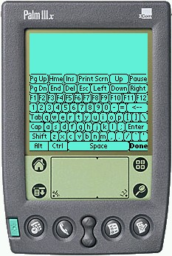 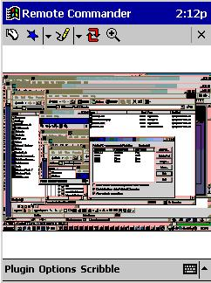
(a) (b)
Fig. 1. Palm (a) and PocketPC (b) Remote Commander screens. The PocketPC version displays a PC’s screen image.
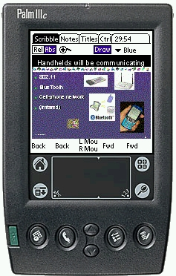 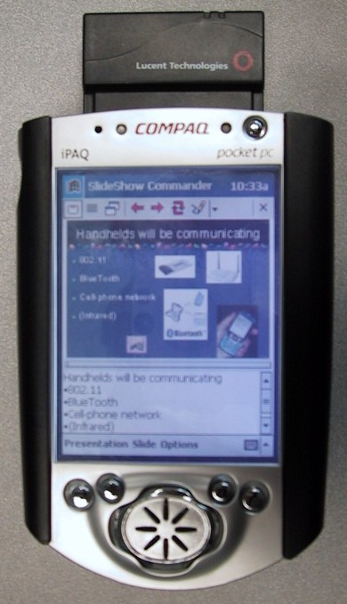
(a) (b)
Fig. 2. SlideShow Commander screens for the Palm (a) and PocketPC (b).
The SlideShow Commander program [8] extends the idea of Remote Commander to provide more information on the handheld for controlling slide shows. When running a PowerPoint presentation on the PC, SlideShow Commander displays a thumbnail picture of the current slide on which the user can scribble with the stylus, as well as the notes for the slide, the list of slides, and other information (Figs. 2(a) and 2(b)). The user can navigate to the next or previous slide, or jump anywhere in the talk. SlideShow Commander also provides facilities to make it easier to switch from presentations to demonstrations and back.
These two programs are examples of using the mobile device for interacting at a distance. Another common way to interact at a distance is using a laser pointer. We have studied the parameters of using a laser pointer tracked by a camera as a computer input device [6]. We discovered that the beam wiggles about 10 pixels due to hand motion, and interactions using laser pointers tend to be slow. Therefore we investigated a new interaction technique called semantic snarfing [9] where the contents (“semantics”) in the area where the beam is pointing are copied (“snarfed”) to the mobile device, and further interaction takes place on the mobile device, where increased accuracy is possible.
When multiple people are interacting with the same shared display, many user interface issues arise. This is called single-display groupware. For example, if there is only one cursor on the shared display, how will users decide who is in control of the cursor? We found that the most effective strategy for such face-to-face sharing was to let whoever wanted to take control do so, but to impose a small timeout before the control was switched to prevent accidental overlapping [11].
In the context of a military environment, called the Command Post of the Future, we studied private drill down of public information. Here, multiple people are sharing public maps and other information displays, so it would be inappropriate for anyone to usurp the big displays for their private use. Instead, there is fluid transfer of information and control between the large public displays and each user’s mobile device [4].
We also investigated uses for mobile wireless devices in a classroom. One application we have studied is instantaneous test taking. We have used PDAs in a second-level chemistry class with about 100 undergraduates to enable the instructor to ask multiple choice questions and get a bar graph of all the student’s answers. This helps keep the students thinking about the material and allows the instructor to evaluate the students’ level of understanding during a lecture. The students reported a strong preference for using the mobile wireless devices over non-computerized alternatives, such as raising their hands or using paper [2].
Most of the above situations involved multiple users. We also studied how individuals working alone might find a mobile device useful even when they had a regular PC available.
Most mobile devices are rechargeable, so it is reasonable for users to put them in a cradle beside the keyboard while at a PC. We studied how a PDA could be used as an extra input device for the non-dominant hand while in this configuration (see Fig. 3(a)). For example, a study showed that the users could scroll and select more quickly using their left hands to scroll with a PDA while their right hands were on the mouse, as shown in Fig 3(a) [7].
(a)
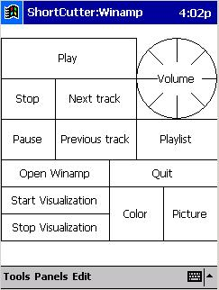 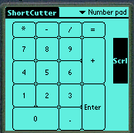 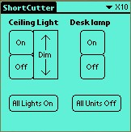
(b) (c) (d)
Fig. 3. PDA on left of a keyboard (a) makes it useful to use Shortcutter on a PocketPC (b) or Palm (c)(d) to control PC applications for an individual.
As a more general application of this concept, we created the Shortcutter program, which allows users to draw a panel of controls on the PocketPC (Fig. 3(b)) or Palm (Figs. 2(c)(d)), and use these panels to control any PC application [8]. The user might create buttons to perform the most common operations. For example, Fig. 3(b) shows a control panel for the Winamp media player.

3 Control of Appliances
A new area we are investigating is how to use mobile devices to control everyday home and office appliances, such as stereos, VCRs, room lights, copiers, etc. These are becoming more complex as embedded computers enable new kinds of functions, but as complexity increases, appliance user interfaces usually get harder to use [1]. Our concept is that each user would use their mobile device as a personal universal controller (PUC) that would allow the user to interact with all the appliances and services in the environment. A PUC could take many forms: an unimpaired user might have a handheld mobile device with a graphical user interface (GUI), whereas a blind user might have an interactive Braille surface or headset that supports speech recognition and speech output. When the user wants to control an appliance, the PUC would communicate with the appliance, download a specification of the appliance’s functions, and then automatically generate a remote-control interface suited to the PUC device and the user. The PUC and the appliance would continue to exchange messages as the user manipulates the interface and as the state of the appliance changes.
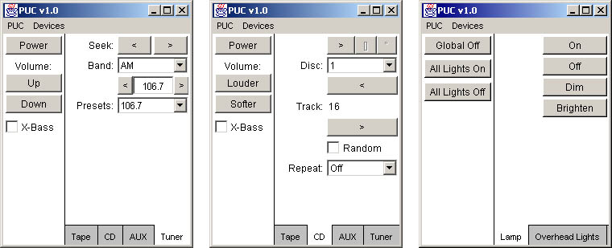
(a) (b) (c)
Fig. 4. Automatically generated interfaces for an Audiophase shelf stereo with its CD (a) and tuner (b); and for a system to control room lights (c).
We approached the PUC project by first hand-designing user interfaces, and then studying how well they performed [15]. We were encouraged by the results, which showed that for both simple and complex tasks, user were able to use our handheld interfaces in about ½ the time with ½ the errors of using the manufacturer’s interfaces. Based on our user studies and hand-designs, we developed a set of requirements for the specification language [13]. We now are developing algorithms that will automatically generate high-quality graphical and speech user interfaces from the specifications [12, 14]. Fig. 4 shows some of the current interfaces that can be generated.

4 Looking Forward
Much of the research in the area of mobile human-computer interaction has focused on the user interfaces to the mobile devices themselves: their input methods and displays. It is important to also study the broader picture and look at how the devices will fit into the users’ entire information and control space. As more and more electronics are computerized and are able to communicate, mobile devices can serve as a personal, portable focal point for interactions with the world. Let us work to have mobile devices improve the user interfaces for everything else, rather than just being additional complex gadgets that must also be mastered.

Acknowledgements
The Pebbles research project is supported by grants from DARPA, NSF, Microsoft, and the Pittsburgh Digital Greenhouse, and equipment grants from Symbol Technologies, Palm, Hewlett-Packard, Lucent, IBM, SMART Technologies, Inc., and TDK Systems Europe, LTD. This research was performed in part in connection with contract number DAAD17-99-C-0061 with the U.S. Army Research Laboratory. The National Science Foundation funded this work through a Graduate Research Fellowship, and under Grant No. IIS-0117658. The views and conclusions contained in this document are those of the authors and should not be interpreted as presenting the official policies or position, either expressed or implied, of the U.S. Army Research Laboratory, the National Science Foundation, or the U.S. Government unless so designated by other authorized documents. Citation of manufacturer’s or trade names does not constitute an official endorsement or approval of the use thereof.

References
1. Brouwer-Janse, M.D., Bennett, R.W., Endo, T., van Nes, F.L., Strubbe, H.J., and Gentner, D.R. “Interfaces for consumer products: "how to camouflage the computer?"” in CHI'1992: Human factors in computing systems. 1992. Monterey, CA: pp. 287-290.
2. Chen, F., Myers, B., and Yaron, D., Using Handheld Devices for Tests in Classes. Carnegie Mellon University, School of Computer Science Technical Report no. CMU-CS-00-152 and Human Computer Interaction Institute Technical Report no. CMU-HCII-00-101, July, 2000. Pittsburgh, PA. http://www.cs.cmu.edu/~pebbles/papers/CMU-CS-00-152.pdf.
3. Haartsen, J., Naghshineh, M., Inouye, J., Joeressen, O.J., and Allen, W., “Bluetooth: Vision, Goals, and Architecture.” ACM Mobile Computing and Communications Review, 1998. 2(4): pp. 38-45. Oct. www.bluetooth.com.
4. Myers, B., Malkin, R., Bett, M., Waibel, A., Bostwick, B., Miller, R.C., Yang, J., Denecke, M., Seemann, E., Zhu, J., Peck, C.H., Kong, D., Nichols, J., and Scherlis, B., Flexi-modal and Multi-Machine User Interfaces. submitted for publication, 2002. http://www.cs.cmu.edu/~cpof/papers/cpoficmi02.pdf.
5. Myers, B.A., “Using Hand-Held Devices and PCs Together.” Communications of the ACM, 2001. 44(11): pp. 34-41.
6. Myers, B.A., Bhatnagar, R., Nichols, J., Peck, C.H., Kong, D., Miller, R., and Long, A.C. “Interacting At a Distance: Measuring the Performance of Laser Pointers and Other Devices,” in ACM CHI'2002 Conference Proceedings: Human Factors in Computing Systems. 2002. Minn, MN: pp. 33-40.
7. Myers, B.A., Lie, K.P.L., and Yang, B.-C.J. “Two-Handed Input Using a PDA And a Mouse,” in Proceedings CHI'2000: Human Factors in Computing Systems. 2000. The Hague, The Netherlands: pp. 41-48.
8. Myers, B.A., Miller, R.C., Bostwick, B., and Evankovich, C. “Extending the Windows Desktop Interface With Connected Handheld Computers,” in 4th USENIX Windows Systems Symposium. 2000. Seattle, WA: pp. 79-88.
9. Myers, B.A., Peck, C.H., Nichols, J., Kong, D., and Miller, R. “Interacting At a Distance Using Semantic Snarfing,” in ACM UbiComp'2001. 2001. Atlanta, Georgia: pp. 305-314.
10. Myers, B.A., Stiel, H., and Gargiulo, R. “Collaboration Using Multiple PDAs Connected to a PC,” in Proceedings CSCW'98: ACM Conference on Computer-Supported Cooperative Work. 1998. Seattle, WA: pp. 285-294. http://www.cs.cmu.edu/~pebbles.
11. Myers, B.A., Wobbrock, J.O., Yang, S., Yeung, B., Nichols, J., and Miller, R. “Using Handhelds to Help People with Motor Impairments,” in Fifth International ACM SIGCAPH Conference on Assistive Technologies; ASSETS'02. 2002. Scotland: pp. To appear.
12. Nichols, J. “Informing Automatic Generation of Remote Control Interfaces with Human Designs,” in ACM CHI'2002 Extended Abstracts. 2002. Minneapolis, Minnesota: pp. 864-865. http://www-2.cs.cmu.edu/~jeffreyn/papers/chi2002puc.pdf.
13. Nichols, J., Myers, B.A., Harris, T.K., Rosenfeld, R., Shriver, S., Higgins, M., and Hughes, J. “Requirements for Automatically Generating Multi-Modal Interfaces for Complex Appliances,” in Submitted for Publication. 2002. http://www.cs.cmu.edu/~pebbles/papers/pucICMI.pdf.
14. Nichols, J., Myers, B.A., Higgins, M., Hughes, J., Harris, T.K., Rosenfeld, R., and Pignol, M. “Generating Remote Control Interfaces for Complex Appliances,” in Submitted for Publication. 2002. http://www.cs.cmu.edu/~pebbles/papers/PebblesPUCuist.pdf.
15. Nichols, J.W. “Using Handhelds as Controls for Everyday Appliances: A Paper Prototype Study,” in ACM CHI'2001 Extended Abstracts. 2001. Seattle, WA: pp. 443-444. http://www.cs.cmu.edu/~pebbles/papers/NicholsRemCtrlShortPaper.pdf.
16. V2 Working Group, Universal Remote Console Specification (AIAP-URC) of the Alternate Interface Access Prototocol (AIAP). http://www.ncits.org/tc_home/v2.htm, 2002.
17. Want, R., Schilit, B.N., Adams, N., Gold, R., Petersen, K., Goldberg, D., Ellis, J.R., and Weiser, M., “An Overview of the ParcTab Ubiquitous Computing Experiment.” IEEE Personal Communications, 1995. pp. 28-43. December. Also appears as Xerox PARC Technical Report CSL-95-1, March, 1995.
18. Zigbee Alliance, Zigbee Working Group Web Page for RF-Lite. 2002. http://www.zigbee.org/.

