Using Hand-Held Devices and PCs Together
Brad A. Myers,
Robert C. Miller, Benjamin Bostwick, Franklin Chen, Carl Evankovich, Herb Stiel,
Karen Cross, Adrienne Warmack, Chun-Kwok Lee, YuShan Chuang, Marsha Tjandra,
Monchu Chen, Kin Pou Lie, Bo-chieh Yang and Zack Rosen
Human Computer Interaction Institute
School of Computer Science

Carnegie Mellon University
Pittsburgh, PA 15213
bam@cs.cmu.edu
http://www.cs.cmu.edu/~pebbles

June 8, 2000

Introduction
The age of ubiquitous computing [12] is at hand with computing devices of different shapes and sizes appearing in offices, homes, classrooms, and in people’s pockets. Many environments contain embedded computers and data projectors, including offices, meeting rooms, classrooms [1], and even homes. One little-studied aspect of these environments is how personal, hand-held computers will interoperate with the desktop and built-in computers. More and more people are carrying around programmable computers in the form of Personal Digital Assistants (PDAs) such as a Palm Pilot or Pocket PC (formerly called Windows CE). In the near future, cell-phones and even watches will increasingly be able to participate in the user’s computing and information environment. In the Pebbles project, we are researching the question of how the functions and the user interface can be spread across all of the computing and input / output devices that the user has available to form multi-computer user interfaces. In this way, the hand-held devices can be used to augment the other computers rather than just being a replacement when other computers are not available. Pebbles stands for: PDAs for Entry of Both Bytes and Locations from External Sources.

Multi-Computer User Interfaces
Most developers and researchers have focused on how a hand-held computer can be used to replace a PC when the user is mobile. Our focus is different: how the hand-held and the PC can work effectively together when both are available.
We call these kinds of applications “multi-computer user interfaces (MCUIs).” Important attributes of MCUIs are that they use heterogeneous devices for both input and output, that many of the devices have their own embedded processors, that the devices are all connected and share information synchronously, and that the devices are all co-located and are used by individuals or groups.
MCUIs have a number of interesting properties and design requirements that differ from other styles of user interfaces that have been extensively studied. For example, MCUIs can be compared to:
- Using multiple displays with a conventional graphical user interface (GUI), for example, when multiple monitors are connected to a single PC. In this situation, the displays usually have very similar characteristics and are all controlled by a single set of input devices. In contrast, MCUIs will use different input devices and processors for each display.
- Using a single display as a front-end to multiple processors, for example using the X Windows mechanism or pcAnywhere from Symantec to display another processor’s windows on the user’s display. Here, the user is given the illusion of using only one computer. With MCUIs, each processor has its own display and input devices.
- “Multi-modal” user interfaces, which support other input modalities such as speech and gestures. MCUIs have multiple means for display as well as for input, and span multiple computing devices.
- Most “groupware” work, also called “Computer Supported Cooperative Work (CSCW),” since MCUIs focus on groups that are co-located and where all of the users share some displays and have other devices that are individualized.
We have developed a wide variety of applications and performed a number of user studies to investigate MCUIs. For example, in the Slide Show Commander application, the user’s laptop displays a PowerPoint presentation as usual, but the user’s PDA controls the presentation, and the user can see on the PDA a thumbnail of the current slide, the notes for the slide, the titles of all the slides, and a timer (see Figure 1). The PDA communicates to the laptop using a serial cable or wirelessly using radio or infrared. As another example, scrolling desktop windows using the PDA in the user’s left hand while the mouse is in the user’s right hand (see Figure 2) can be faster than using conventional scroll bars [8].

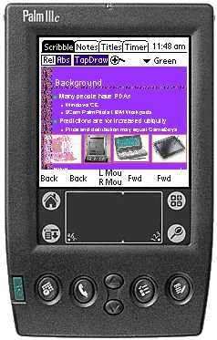 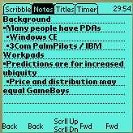 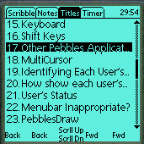 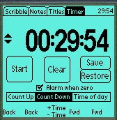
(a) (b) (c) (d)
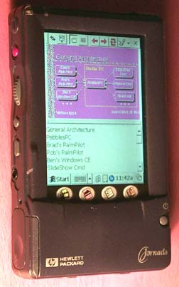 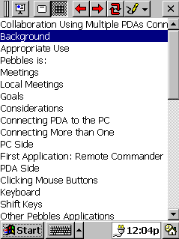
(e) (f)
Figure 1
The Pebbles Slideshow Commander program. (a) A Palm IIIc (color Palm), with the “Scribble” (thumbnail) panel at the front. The other panels for the Palm (showing the screens from a monochrome Palm) are “Notes” (b) “Titles” (c) and “Timer” (d). Meanwhile, a laptop computer is running PowerPoint and the Palm is in continuous two-way communication with the laptop. (e) The Slide Show Commander application running in Windows CE on a HP Jornada, and (f) a detail of the “Titles” view under Windows CE.

Figure 2
Typical configuration when using a PDA along with desktop applications. The PDA in its cradle on the left of the keyboard, and the user’s hands are on the PDA and the mouse. The PDA is running an application such as a Scroller (not apparent in this picture), which the user is operating with his index finger.

RESEARCH ISSUES in Multi-Computer User Interfaces
Creating multi-computer user interfaces exposes a number of research issues and problems that are different from those with conventional user interfaces. Some of these issues are relevant to group work, others deal with how to facilitate individual work, and finally, there are many issues about how the devices will communicate.

Groups
When multiple people meet to work, slides or a current work product may be displayed on a PC, which serves as a focus of discussion and may be edited by the group. We envision that the meeting participants will have hand-held computers with them, and we are exploring ways to effectively use all the devices together. Important research issues include private displays versus shared displays and interaction techniques for multiple users.

Private Displays versus Shared Displays
The information on the PC display is shared among all the users, whereas the information on the hand-held is private to the individual. The challenge is to show the appropriate information in each place, and to allow fluid transfer of state and information between private and shared displays [4] [10]. In the Slideshow Commander application, for example, the group sees only the slide on the shared display, but the presenter’s private display shows the notes for each slide, and a timer (see Figure 1). In a study of PowerPoint presentations [3], a number of problems were identified, including that the speaker often desires to walk away from the presentation computer to be closer to the audience (and some people just like to wander around while talking). It can also be awkward to point to and annotate the slides using a mouse. People also often had trouble when trying to go navigate to the previous slide or to a particular slide. The Slideshow Commander program addresses these problems. First, the PDA can be used while walking around. Second, the physical buttons make it easy to move forward and backwards and the titles pane (Figure 1(c) and (f)) makes it easy to jump to particular slides. Finally, the user can scribble with the stylus on the slide thumbnails on the PDA (Figure 1(a) and (e)), and these annotations will be shown to the group. In the future, we will be exploring an audience mode for Slideshow Commander, where private scribbles and notes can be saved on each hand-held, and the presenter can call on an individual who can then move the desired information to the public screen.
Another application that we are exploring is the use of multiple hand-helds along with large displays in a military command post. The big wall displays show maps, visualizations of status or plans, or other information that is shared by all in the room. Each person’s hand-held can be used to control the large displays, and to privately get more details about publicly displayed data. In our multi-modal command post, the hand-held devices provide a convenient platform for handwriting and gesturing, since it can be awkward to write directly on the large displays. We are also investigating various ways to use the hand-helds to flexibly enter and carry information, so people can easily and quickly enter their specific knowledge, and easily move data between private and public views.

Interaction Techniques for Multiple Users
Often different people in the meeting will want to take turns controlling the mouse and keyboard to add annotations or input, to try out a system under consideration, or to investigate different options. With standard configurations, they will have to awkwardly swap places with the person at the PC or try to tell the person what to do. The Remote Commander application allows each person to use his or her own hand-held device to control the cursor and keyboard of the main PC display. Remote Commander provides three different ways for multiple people to control a single PC. First, each person can take turns controlling the PC’s cursor and keyboard input. This allows the hand-helds to control all existing applications, but only one person can be working at a time. The second option is for each person to have their own cursor that appears to float above all applications. This allows everyone to point and scribble on the screen simultaneously, but the cursors cannot control regular PC applications, which can only accept input from a single cursor. Finally, for custom applications that support it, each person can have a separate cursor that controls the application.

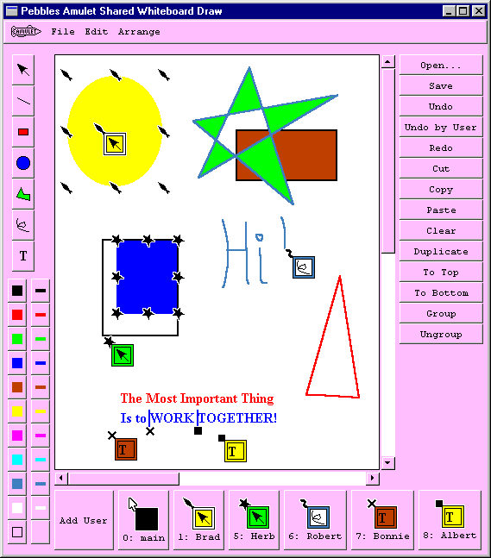
Figure 3
PebblesDraw, a shared drawing program that gives each user a private cursor and selection handles.
We have created a custom drawing program, called PebblesDraw [9], to investigate the interesting issues arising from this shared use (see Figure 3). When all users are sharing the same screen and therefore the same widgets, applications are called “Single Display Groupware” [11]. The user interface issues here are different from those of conventional groupware applications, such as Microsoft NetMeeting, since those assume that each person has a separate display. When all users share a single display, the widgets and interaction techniques must change.
For example, palettes, such as those to show the current drawing mode or the current color, normally show the current mode by highlighting one of the items in the palette. This no longer works if there are multiple users each with a different mode and color. Therefore, in PebblesDraw, each user’s modes are shown in their “home area” at the bottom of the window, as well as in their cursor. Furthermore, the conventional menu-bars at the top of the window or screen may be inappropriate for multi-user situations because menus may pop up on top of a different user’s activities. To address this, we provide a fixed menu (on the right of Figure 3) containing the most common commands, as well as the usual keyboard shortcuts (which can be invoked from each user’s PDA).
The conventional way to identify different users in groupware is by assigning each a different color, but this has been shown to be confusing in a drawing program since the color identifying the user can be mixed up with the color with which the user will draw. Therefore, PebblesDraw assigns each user a different shape. The shape is used for the cursor that follows the mouse, as well as for that user’s selection handles and text-input cursor.
Since the users’ selections are independent, they can be performing different operations at the same time. The system ensures that something reasonable happens if two users operate on the same objects. For example, if one person deletes an object while another is changing its color, the object disappears, but if the deletion is undone, then the object will have the new color. As another example, if two people resize the same object, it grows to the sum of both sizes. All of the shared controls (such as the menus and palettes) can only be operated by one user at a time. Since one user might have objects selected and another may not, the controls cannot gray out illegal actions until a particular user clicks on them. For example, in Figure 3, if Bonnie clicks on the “Cut” button, it will immediately gray-out and not perform any operation since she does not have objects selected. However, since Brad has the oval selected (shown by the spear-head-shaped handles around the oval), when Brad selects the Cut button, it will be displayed normally, and if pressed, the oval will be removed.
PebblesDraw must also handle the usual Groupware issues, such as how to deal with Undo. PebblesDraw supports both undo-by-user and global undo. If a user selects undo-by-user, then that user’s previous command is undone, if possible. This is implemented using a “selective undo” mechanism [7] provided by the underlying Amulet toolkit with which PebblesDraw was implemented. For the future, we are looking at possibly moving some of the PebblesDraw controls onto the hand-held, so the main screen can contain fewer palettes and menus. This brings up many interesting design issues, such as how panels on the hand-held should be designed (see [10] for one approach), how to represent colors and other properties that cannot be directly shown on a monochrome hand-held display, and how to make it easier for implementers so they do not have to design screens and write code for the PC as well as for each possible type of hand-held.

Individuals
When a person walks into their office or home carrying a PDA, how will it interact with other computers in the environment? We have identified two important research issues in multi-computer user interfaces for individuals: using multiple computers at the same time to control an application, and sharing information among the computers.

MCUIs for Controlling an Application
In the “old days,” computers had a variety of input switches and knobs. Today, computers are standardized with just a keyboard and a mouse for input, and connecting custom input devices is difficult and expensive. Although today’s computers have high-resolution screens and window managers, users can still need extra space to display information. For people who have already purchased a PDA, we want to exploit it to provide the benefits of having an extra input and output device. For example, Figure 2 shows the PDA being used at the same time as the mouse as an extra input and output device for the non-dominant hand. Some of the newest PDAs such as the Palm V and the HP Jornada 430 have rechargeable batteries that are recharged when the device is in its cradle. Therefore, the user is supposed to leave the device connected to the PC whenever the user is next to the PC, so the device might as well be doing something useful.
The PDA can be used to extend the desktop in various ways. It can serve as a customizable input device, with on-screen buttons, sliders, menus and other controls displayed on the screen. These can be made big enough to operate with a finger, even with the non-dominant hand. The interfaces can then be carried around, and used with different PCs. The PDA can also be used as an output and control device to provide secondary views. This is useful when the entire PC screen is engaged and unavailable. For example, the WinAmp MP3 player for PCs can display on the full PC screen an animation based on the music, and a PDA can be used to control playback without interrupting the display (see Figure 4e). Another use is to display information that should not be covered by other windows, for example to display a list of tasks and windows on the PDA to support easy switching. We are also studying how to integrate hand-helds into the user’s entire information space.
We investigated a number of ways to scroll using a PDA. Figure 4b shows some buttons which auto-repeat to scroll up and down a line or a page, or left and right. On the left and bottom of Figure 4-b are sliders, where dragging a finger or stylus drags the text the same amount. The center of Figure 4-b contains a virtual rate-controlled joystick, where pressing in the center and moving out scrolls the text in that direction at a rate proportional to the distance. A user study demonstrated that these could match or beat scrolling using the mouse with conventional scroll bars, as well as other scrolling mechanisms such as the “scroll wheel” built into mice and other two-handed scrolling techniques [8]. Users were fastest with the scroll buttons and slowest with the rate-controlled joystick, although it is clear that all the scrollers can be improved with more iterative refinement. As part of the same study, we measured how long it takes a person to move from the keyboard to acquire input devices, and found that the penalty for moving both hands (the left hand to the PDA and the right hand to the mouse) is only about 15% slower than moving just the right hand to the mouse and leaving the left hand on the keyboard. The average times were about 728 msec to move to just the mouse and 701 msec to move back to the keyboard from the mouse, compared to 838 msec to move both hands to the PDA and the mouse, and about 791 msec to move back to the keyboard. Thus, adding the use of a PDA to the conventional mouse and keyboard does not provide a significant penalty.

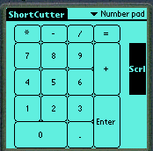 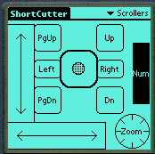 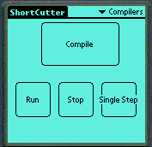
(a) (b) (c)
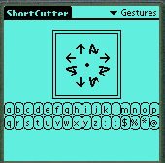 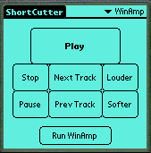 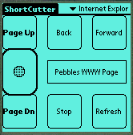
(d) (e) (f)
Figure 4
Panels created with Shortcutter: (a) a numeric keypad, (b) a collection of scrollers and a knob, (c) buttons for controlling any of a set of compilers, (d) a gesture pad and two rows of small buttons, (e) a controller for the WinAmp PC program which plays music files, and (f) a panel for browsing in Internet Explorer.
For general application control, the Shortcutter program allows panels of controls to be drawn on the PDA, and used to control any PC application. Shortcutter can provide customizable interfaces on the PDA even for applications that do not have a customization facility on the PC. Figure 4 shows some panels we have created. Shortcutter’s widgets include various kinds of buttons, sliders and knobs and a gesture-recognizer (Figure 4d). Various actions can be associated with each widget, including sending keyboard keys as if the user typed them, scrolling, sending menu and toolbar commands, invoking applications and opening files, switching to different panels, and macros containing a sequence of other actions.
Another PDA application, called Switcher, displays a list on the PDA of the current PC tasks (like the Windows Taskbar) and a list of the windows in each task (like the Windows menu in some applications). This eliminates the confusion of which of these very different mechanisms to use to get to a desired window, and provides a consistent, quick, and always-available mechanism. The user can tap on an item on the PDA to cause that window to come to the front of the PC. This same mechanism also allows the buttons in Shortcutter to be application-dependent. For example, we use many different compilers in our work, and unfortunately they use different shortcut keys as accelerators for various operations such as Compile or Run (and none are customizable to allow these shortcut keys to be changed). With Shortcutter, we can create a single button on the PDA, shown in Figure 4c, which checks which compiler is currently in the front of the PC, and sends the accelerator key appropriate to that compiler.

Sharing Information
Another important issue is how to fluidly transfer information between devices in a multi-computer user interface. For example, “HotSync” allows all of the information in a Palm to be synchronized with a PC. Similarly, Microsoft provides “ActiveSync” for Windows CE devices. However, these operations copy all of the information from the PDA to the PC, which is not appropriate in many situations, especially when trying to share a specific piece of information with another person. To provide a quicker and more convenient way to selectively move information, we adopt the familiar “Cut and Paste” model, but extend it to operate across machines. Whenever the user copies or cuts text on any of their machines, it can be pasted on another. File names or URLs can also be pasted onto the PDA, and a command on the PDA will cause the PC to open the application associated with the file, or open the web page in the default browser. This allows information on the PC to be copied to the PDA either by value or by reference. If the user copies the information itself and pastes it to the PDA, this corresponds to passing the information “by value.” If the user copies the filename or URL of the information, then it is passed “by reference.” In this way, the PDA can carry pointers to information that resides elsewhere. The Remote Clipboard PDA application provides one place to store the data on the PDA, but the information can be pasted and copied from any PDA application, including the address book, scheduler, MemoPad, etc.
Research [2] and experience show that web browsing often takes on a “hub and spoke” style, where the user frequently returns to a main index page (the “hub”) in order to find the next out-link to click on. Examples include the results of a search, and the table of contents for web sites and on-line documents. The Web Assistant application aids in these tasks by allowing links from the hub page to be copied to the PDA. For links that are pictures, the “alt” text is displayed. If there is no “alt” text, then the URL is displayed instead. Clicking on a link causes the web browser on the PC to switch to the specified page. The PDA display continues to show the hub page’s links so the user can easily move from spoke to spoke. Pressing a button refreshes the PDA with the current page’s links so it can serve as the new hub.

Communication
The general architecture of Pebbles is shown in Figure 5. The main components are client programs running on (one or more) PDAs, server programs running on the PC, and PebblesPC, a PC program that mediates between clients and servers.
We are experimenting with many different ways for the hand-held devices to communicate with each other and the PCs. The simplest and cheapest is to use the cradles or serial cables that are supplied with most of today’s PDAs. For Palm Pilots and many Windows CE devices, you can buy serial cables to use instead of the cradles, which are often more convenient, such as when the user is standing and using Slide Show Commander to give a talk.

Figure 5
The Pebbles architecture.
An even more attractive option is a wireless connection for the hand-held. Pebbles supports infrared (IR) communication, since IR is built into most PDAs. Unfortunately, IR is not suitable for most of our applications because it is highly directional and quite short range. A better alternative is radio frequency (RF) communication. Carnegie Mellon University is installing a Wavelan wireless network from Lucent throughout the campus, in a project called “Wireless Andrew” [6]. Pebbles supports Windows CE hand-held computers connecting using a Wavelan PCMCIA card. Unfortunately, there are currently no Wavelan cards for small palm-size devices, but we expect these to be available soon. The BlueTooth standard for small device wireless radio communication [5] will also be available in the near future, and most PDAs, cell-phones, and other computerized small devices are expected to support it. BlueTooth seems like an ideal technology for many of our applications. Pebbles also supports Palm and Windows CE devices modified by Symbol Technologies to have a radio connection.
Pebbles client programs run on various PDAs. Most of our applications run on both Palm and Pocket PC (Windows CE) devices. Multiple PDAs can be connected to the same PC to support the groupware applications discussed above. Server programs run on the Windows PC. Our architecture supports two kinds of servers. The first kind uses plugins, which are dynamic link libraries (DLLs) loaded into PebblesPC’s address space. The second kind of server is a separate process, running either on the same PC or a remote host, and communicating with PebblesPC through a network socket.
Servers perform their operation in various ways, with various levels of application independence. For example, the Slideshow Commander server interacts directly with PowerPoint through OLE Automation. At the other extreme, the Scroller server simulates scrolling by inserting keystrokes and Windows messages into the standard Windows event stream.
PebblesPC acts as both a naming service and a message router. A server makes itself available to clients by connecting to PebblesPC and registering its name. Clients connect to a server by first connecting to PebblesPC and requesting a server name. If a server by that name is available, then PebblesPC makes a virtual connection between the client and the server, routing messages back and forth. PebblesPC allows clients and servers to connect through heterogeneous I/O interfaces, including serial ports, infrared, network sockets, and Windows message passing. PebblesPC handles the low-level details of each interface.

STATUS AND Future Work
Most of the applications described here are available for general use from our web site: http://www.cs.cmu.edu/~pebbles. The Slideshow Commander application is being released commercially by Synergy Solutions (http://www.synsolutions.com/software/slideshowcommander/). We are actively pursuing new applications and issues in multi-computer user interfaces. For example, we are giving hundreds of hand-helds donated by Hewlett-Packard to students in large lecture classes, to investigate the issues raised by scaling up to large classroom use.
There are many open questions to be investigated in the area of multi-computer user interfaces. We would like to generalize from the specific applications to develop lessons and rules-of-thumb to help guide future user interface designs. With the coming wireless technologies, connecting the PCs and PDAs together will no longer be an occasional event for synchronization. Instead, the devices will frequently be in close, interactive communication. We are pursuing the research needed to help guide the design of interfaces that will run in this environment and span multiple computers.

ACKNOWLEDGMENTS
For help with this paper, we would like to thank the referees, Bernita Myers, and all the users of the Pebbles applications who have provided useful feedback.
This research is supported by grants from DARPA and Microsoft, and equipment grants from Palm, Hewlett-Packard, Lucent, Symbol Technologies, and IBM. This research was performed in part in connection with contract number DAAD17-99-C-0061 with the U.S. Army Research Laboratory. The views and conclusions contained in this document are those of the authors and should not be interpreted as presenting the official policies or position, either expressed or implied, of the U.S. Army Research Laboratory or the U.S. Government unless so designated by other authorized documents. Citation of manufacturer’s or trade names does not constitute an official endorsement or approval of the use thereof.

References
1. Abowd, G.D., Atkeson, C.G., Brotherton, J.A., Enqvist, T., and Gully, P. “Investigating the capture, integration and access problem of ubiquitous computing in an educational setting,” in Proceedings SIGCHI'98: Human Factors in Computing Systems. 1998. Los Angeles, CA: pp. 440-447.
2. Card, S.K., Robertson, G.G., and York, W. “The WebBook and the Web-Forager: An Information Workspace for the World-Wide Web,” in Proceedings CHI'96: Human Factors in Computing Systems. 1996. Vancouver, BC, Canada: pp. 111-117.
3. Cross, K. and Warmack, A. “Contextual Inquiry: Quantification and Use in Videotaped Analysis,” in CHI'2000 Extended Abstracts; Conference on Human Factors in
Computing Systems. 2000. The Hague, The Netherlands: pp. 317-318.
4. Greenberg, S., Boyle, M., and Laberg, J., “PDAs and Shared Public Displays: Making Personal Information Public, and Public Information Personal.” Personal Technologies, 1999. 3(1): pp. To appear. March.
5. Haartsen, J., Naghshineh, M., Inouye, J., Joeressen, O.J., and Allen, W., “Bluetooth: Vision, Goals, and Architecture.” ACM Mobile Computing and Communications Review, 1998. 2(4): pp. 38-45. Oct. www.bluetooth.com.
6. Hills, A., “Wireless Andrew.” IEEE Spectrum, 1999. 36(6)June.
7. Myers, B.A. and Kosbie, D. “Reusable Hierarchical Command Objects,” in Proceedings CHI'96: Human Factors in Computing Systems. 1996. Vancouver, BC, Canada: pp. 260-267.
8. Myers, B.A., Lie, K.P.L., and Yang, B.-C.J. “Two-Handed Input Using a PDA And a Mouse,” in Proceedings CHI'2000: Human Factors in Computing Systems. 2000. The Hague, The Netherlands: pp. 41-48.
9. Myers, B.A., Stiel, H., and Gargiulo, R. “Collaboration Using Multiple PDAs Connected to a PC,” in Proceedings CSCW'98: ACM Conference on Computer-Supported Cooperative Work. 1998. Seattle, WA: pp. 285-294.
10. Rekimoto, J. “A Multiple Device Approach for Supporting Whiteboard-based Interactions,” in Proceedings SIGCHI'98: Human Factors in Computing Systems. 1998. Los Angeles, CA: pp. 344-351.
11. Stewart, J.E. “Single Display Groupware,” in SIGCHI'97 Adjunct Proceedings: Human Factors in Computer Systems, Extended Abstracts. 1997. Atlanta, GA: pp. 71-72.
12. Weiser, M., “Some Computer Science Issues in Ubiquitous Computing.” CACM, 1993. 36(7): pp. 74-83. July.

This paper uses the terms PDAs and hand-held computers interchangeably, since most of the ideas in this paper would equally apply to any of these devices. Our research has so far focused on using PDAs such as Palm Pilots and Windows CE devices. We will use “PC” to refer to a desktop computer, which might actually be a laptop or a wall-mounted display connected to a computer embedded in a room, and therefore not necessarily only for desks.
Any remote users not in the same room can use conventional group applications such as Microsoft NetMeeting, which interoperate with the Pebbles applications.
It may not be possible, for example, if a different user has in the interim deleted the object that this user was working on.

