Proposal to Symbol Technologies, Inc. for
Funding for the
Pebbles Research Project;
Using Handheld Devices Along With Regular PCs

Brad Myers
Human Computer Interaction Institute

Carnegie Mellon University
Pittsburgh, PA 15213
(412) 268-5150
bam@cs.cmu.edu
http://www.pebbles.hcii.cmu.edu/

Executive Summary
Personal digital assistants (PDAs) like the Palm and PocketPC devices are becoming increasingly ubiquitous, and with wireless technologies such as Spectrum 24, IEEE 802.11, and BlueTooth, they will frequently be in close interactive communication with other devices and each other. Furthermore, cell-phones and pagers, which primarily used for communication, are increasingly becoming programmable. We are investigating many ways in which these kinds of handheld devices can be used to enhance the interaction with desktop and home PCs, and with computers embedded into meeting rooms, classrooms and “smart homes.” Since Symbol is a leader in computerized communicating devices, our research is highly relevant to Symbol’s mission. Our existing applications have received wide recognition for their creativity and usefulness. For example, one application allows people in a meeting to use their handhelds to control the cursor and keyboard of the main projected PC or to scribble on the screen, so participants can add their comments without leaving their seats. Another application allows a speaker to see the slides, notes, list of titles and time of their PowerPoint presentation on their handheld, and to switch slides and scribble on the current slide. This application makes particularly good use of the Symbol SPT 1750 since the screen is used to visualize and control the slide show, the Spectrum 24 radio is used to communicate with the PC to control PowerPoint, and the laser is used as a laser pointer when the user wants to point directly at the screen. In the future, we propose many new research directions, including how to use handhelds as “universal remote controllers” for physical devices such as lights, phones, audio/visual equipment, copiers, factory equipment, etc. Another topic is fluid transfer of information and control between public and private displays, for example in meetings. We are investigating many techniques for visualizing and editing shared information, enhancing collaboration and communication among people and their devices. A closer relationship between Symbol and our research group will be mutually beneficial, and we hope that Symbol will make a substantial grant to the Pebbles research project.

Overview of the Pebbles Project
The age of ubiquitous computing is at hand with computing devices of different shapes and sizes appearing in offices, homes, classrooms, and in people’s pockets. Many environments contain embedded computers and data projectors, including offices, classrooms, meeting rooms, and even “smart” homes. One little-studied aspect of these environments is how personal, handheld computers will interoperate with the desktop computers. More and more people are carrying around programmable computers in the form of Personal Digital Assistants (PDAs) such as Palm and PocketPC devices, and even cell-phones and watches are becoming programmable. We are researching the question of what users can do with their handheld computers in such an environment.
Some researchers have looked at using handheld devices in group settings to support collaborative work, usually with custom applications. However, there has been little study of how portable devices can work in conjunction with the Windows desktop user interface, and with conventional Windows applications. Most of the research and development about handheld computers has focused on how they can be used to replace a regular computer for when one is not available. The conventional model for PDAs is that the data is “synchronized” with a PC once a day using the supplied cradle, and otherwise the PDA works independently. This will soon change. Symbol’s handhelds provide the Spectrum 24 network that can be communicating continuously. CMU has installed a Lucent Wavelan wireless network (which implements the IEEE 802.11 wireless standard) throughout the campus, in a project called “Wireless Andrew” [Hills 1999]. Many PocketPC and Windows CE handheld computers can be connected to this wireless network using a PCMCIA card (although this is not an ideal solution since 802.11 has a high-demand for power and drains the batteries quickly). Next year, the BlueTooth standard for small device wireless radio communication will hopefully be available, and most PDAs, cell-phones, and other computerized small devices are expected to support it. Therefore, we expect that connecting the PCs and handhelds together will no longer be an occasional event for synchronization. Instead, the devices will frequently be in close, interactive communication.
We are studying how the handheld computer’s display, input mechanisms, and processor can be used to enhance the desktop computer’s application when they are communicating. For example, the handheld can provide extra views of the data on the PC, and there can be buttons on the handheld that control the PC’s applications. Thus, rather that trying to repeat the user’s desktop and desktop applications on the handheld, we use the handheld to augment and enhance the existing PC with the user interface spread across the multiple devices. We call this Multi-Machine User Interfaces (MMUIs). Another focus is how the user’s information and control can fluidly move among the devices.
Some of our existing applications include:
- Applications for Presentations: Our SlideShow Commander (shown in Figure 1) allows the presenter to remotely control a PowerPoint presentation running on a PC. On the handheld is shown a thumbnail and the notes of the current slide, the list of titles, and a timer. The user can move forward and backwards through the show or jump to a particular slide, and can scribble on the thumbnail and the same drawings will appear on the main screen. The Symbol SPT 1750 is a particularly good platform for the SlideShow Commander, since we use the Spectrum 24 network to communicate with the PC, and we use the laser as a laser pointer. SlideShow Commander has been licensed for commercial sale (see http://www.slideshowcommander.com/).
- Applications for Meetings: We have created a variety of applications for group use in meetings. These are summarized in a paper at the last Computer-Supported Cooperative Work conference [Myers 1998]. All of these work with the Symbol SPT 1750 and PPT 2700 with the Spectrum 24 network. With RemoteCommander, each person can use his or her own handheld to control the real cursor and keyboard of the main computer, to enhance collaboration. We are performing studies of “floor control” mechanisms to help reduce interference among the users [Myers 2000b]. With the Scribble application, users can each have their own cursor and can scribble independently on the main screen, controlled by the handheld. MultiCursor allows each person to have their own independent control in custom applications that support multiple cursors (for example, the drawing program shown in Figure 2). We have explored a number of issues in how multiple people can share a single application on the big screen [Myers 2000a]. In addition, we have a little chat program that allows people in meetings to have side conversations.

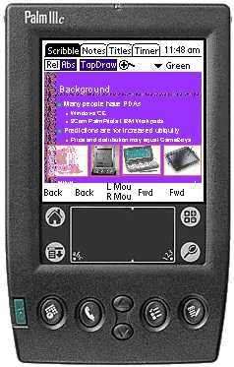 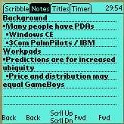 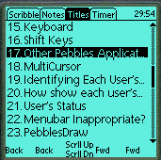 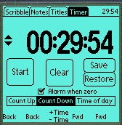
(a) (b) (c) (d)
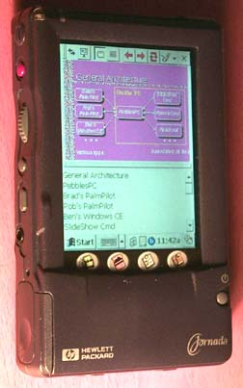 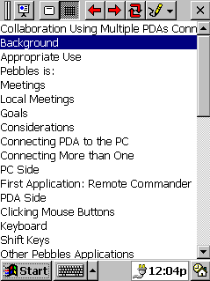
(e) (f)
Figure 1
The Pebbles Slideshow Commander program. (a) A Palm IIIc (color Palm), with the “Scribble” (thumbnail) panel at the front. The other panels for the Palm are “Notes” (b) “Titles” (c) and “Timer” (d). Meanwhile, a laptop computer is running PowerPoint and the Palm is in continuous two-way communication with the laptop. (e) The Slide Show Commander application running in Windows CE on a HP Jornada, and (f) a detail of the “Titles” view under Windows CE.
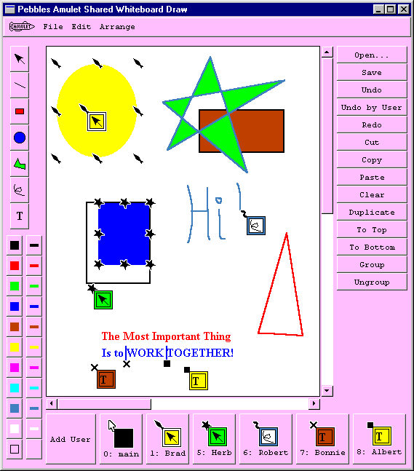
Figure 2
PebblesDraw, a shared drawing program that gives each user a private cursor and selection handles controlled by their PDA. Brad has the yellow oval selected while Herb is growing the blue rectangle. Bonnie and Albert are both editing the text string, while Robert is drawing some freehand letters.
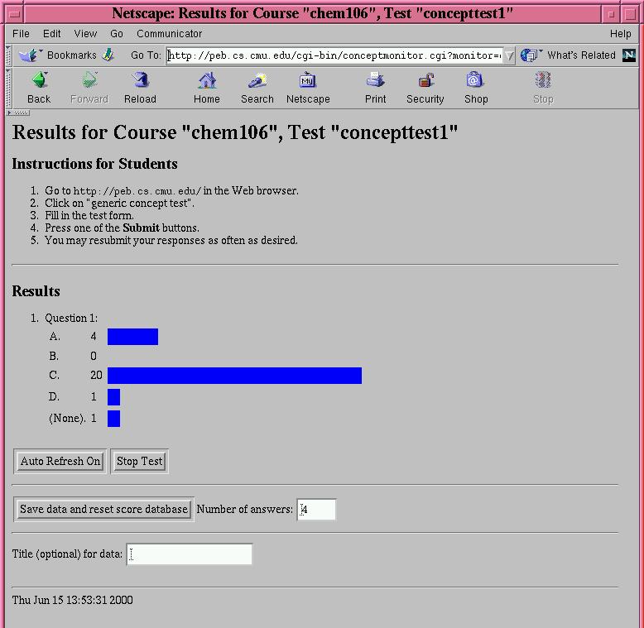
Figure 3
Instructor’s display for our educational application, showing a chart of the current answers from the students.

- Applications for Education: We are exploring some of the educational benefits of each student having their own handheld. Last spring, we gave each student in a freshman chemistry class a Jornada 680 donated by Hewlett Packard with a Wavelan (802.11) wireless card, donated by Lucent. This allowed the students to use the CMU wireless Andrew network system [Hills 1999] anywhere on campus. In the classroom, we investigated how “concept tests” [Mazur 1997] could be used to enhance learning in the large lectures. As many as 5 or 6 times in a lecture, the professor would stop and ask a multiple-choice question which the students had to answer using their wireless handheld. The professor’s PC displayed a chart of the results, which could optionally be displayed for the class (see Figure 3). This form of testing seemed to keep the students more engaged, and allowed the professor to more accurately determine whether the students understood the material. A survey showed that the students thought this technique was very valuable and that they liked using the handhelds [Chen 2000].
- Applications for Individuals: Many of the newer handheld devices, including the Symbol PPT 2700 and the SPT 1750, are rechargeable. This means that users are supposed to put them in their cradle when at their desks (see Figure 4-a). We are investigating a wide variety of ways the handhelds can enhance desktop applications when in the cradle. For example, in a study last year, we showed that using the handheld for scrolling could be faster than using the mouse and scroll bars, or special scrolling mechanisms like the wheel on the Microsoft mouse [Myers 2000c]. Another application allows the user to create panels of buttons, scrollers, dials, and mouse pads to control any PC application (see Figure 4d-e). We are now extending this work to see how Shortcutter and the RemoteCommander can be used to help handicapped individuals use PCs. For example, certain people with Muscular Dystrophy have found that our applications are easier to use than conventional keyboards and mice, yet are far cheaper than custom devices specifically designed for the handicapped.

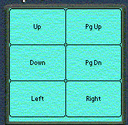 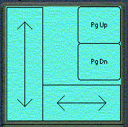 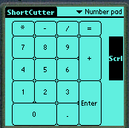 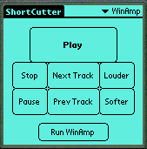
(a) (b) (c) (d) (e)
Figure 4
(a) Typical configuration when using a PDA along with desktop applications. The PDA in its cradle on the left of the keyboard, and the user’s hands are on the PDA and the mouse. The PDA is running an application such as a Scroller (not apparent in this picture). (b) and (c) are scrollers on the Palm screen for scrolling the PC. (d) is a numberpad, and (e) is a controller for the WinAmp media player created using Shortcutter.
- Applications for the Military: As part of the “Command Post of the Future” initiative, we are investigating how handhelds can fit into an advanced, multimodal command post. For example, the commander may be using speech and gesture to control a main map display, while staff people are walking around using handhelds to “drill-down” to explore specific information shown on the main display. The handhelds can also be used to fluidly move information and transfer control back and forth among the individual and shared displays. The Symbol devices may be attractive for military applications of this sort since they are ruggedized.

Future Research
We have many exciting ideas for future research on how handheld devices can be used to augment interaction with regular computers and other computerized equipment.

Universal Remote Controller
We propose to investigate how handheld devices can be used to control all kinds of home, office and factory equipment. The concept is that when users point their own handheld at a light switch, at a photocopier in an office, at a machine tool in a factory, at a VCR at home, at a piece of test equipment in the field, or at almost any other kind of device, the device will send to the handheld a description of its control parameters. The handheld will then use this information to create an appropriate control panel, taking into account the properties of the controls that are needed, the properties of the handheld (the display type and input techniques available), and the properties of the user (what language is preferred, whether left or right handed, how big the buttons should be based on whether the user prefers using a finger or a stylus). The user can then control the device using the handheld. The device will not need to dedicate much processing power, hardware, or cost to the user interface, since it will only need to contain a description of its capabilities and storage for the current settings, along with hardware for wireless communication. The handheld programs will use intelligent “model-based” techniques to create useful and appropriate interfaces that are customized for each user.
An important motivation for the proposed research is the increasing complexity of consumer and business devices. Most desk phones, cell phones, clock radios, VCRs, stereos, washing machines, microwave ovens, thermostats, photocopiers, fax machines, etc. have many unused features. Most consumers find it difficult to master the basic functions of some of these devices, never mind the sophisticated features. Even simple devices are not immune to this problem; when traveling, I am frequently stumped by the user interface for setting the alarm on the clocks in hotel rooms.
The approach of the proposed Universal Personal Controller aims to alleviate these problems. Wouldn’t it be nice to be able to point your own PDA at the hotel clock and use a familiar and well-designed user interface on the PDA to set the alarm? We envision devices of the future that will be able to describe at a high-level their control parameters so that a mobile handheld will be able to construct or find an appropriate control panel. By off-loading the user interface onto a user’s handheld, more money and effort can be spent on the handheld controller than would be practical for the devices being controlled. Furthermore, we expect that the user interface on the Universal Personal Controller will be better than the user interface of today’s remote controls.
The research we propose will focus on the user-interface aspects of this problem: how to generate high-quality and usable control panels on handheld devices. We will also work with our partners on the “service discovery” protocols that allow our device to discover what equipment is available to be controlled and the properties of that equipment. An inexpensive Symbol device may be an ideal platform for this remote controller idea. The laser scanner might be useful for identifying equipment, and radio communication may be useful for interacting with the equipment, especially if such standards as BlueTooth or 802.11 are widely used, as expected.

Using Laser Pointers
A number of previous systems have explored using computer vision to track the dot from a laser pointer on a projected computer image. These have proven to be relatively unpopular, and commercial versions have been withdrawn. We are researching ways to overcome problems identified with early systems, and also to take advantage of the unique properties of the Symbol SPT 1750 which has the laser coupled with a handheld containing a display and radio. It is difficult to use a laser pointer to interact with a projected screen because the user’s hand shakes and cameras are inaccurate, so the positioning is very low resolution. Another problem is that the laser pointer has no “mouse button” to signal when the position is of interest. We propose a three-step process where the laser pointer is first used to point to the general region of interest, then, this area is uploaded onto the handheld screen for detailed interaction, and finally, the result is sent back to the PC when the editing is complete. An important component of this research is what we call “semantic grabbing.” It will not be sufficient to just copy a small square of the screen and show it on the handheld, because it would be too difficult to interact with. Therefore, we must convert the PC’s contents into a usable format. For example, if the user points in the vicinity of a menu or toolbar on the PC, we reformat the menus into Palm format and display the Palm menu on the handheld. Similarly, if the user points at some text, we read that text into a Palm text field, allowing the user to edit using conventional Palm mechanisms, and then replace the PC’s text with the new content after editing. For certain applications, such as Microsoft Office, we can even add drawings from the handheld into the appropriate place in the document on the PC.

Educational Uses
We propose to continue next semester the study from last spring on using handheld computers in the classroom. This time, we hope to more formally measure the impact of the concept tests and handhelds on the educational experience. In addition, we are interested in exploring other uses of connected handhelds in education. For example, many laboratory exercises involve students recording data, which might be aggregated and graphed on the instructor’s main screen. Techniques from our SlideShow Commander can be used when the instructor is presenting from PowerPoint to bring a copy of the slides and notes to the students’ handhelds. The student could then add his or her own private notes to the public record, and save the information for later study.

Relationship to Symbol's Interests
We believe that the current and future research of the Pebbles project is highly relevant to Symbol Technologies. As a world leader in mobile data management systems and services, Symbol is interested in novel ways for the handhelds to integrate with and control the global information space. Symbol’s devices already demonstrate the benefits of having handhelds able to continuously communicate with PCs and other computerized equipment, and our research will help expand the reach of these technologies, especially as the price inevitably drops. Symbol has a focus on educational applications, primarily for teachers and administrators (http://www.symbol.com/solutions/education/education_white_papers_teach.html), and our research can point the way towards more ubiquitous use for students as well.
I have already established good relations with the Pittsburgh-based Symbol group, and I presented an overview of this research at the Pittsburgh site on August 25, 2000. Symbol’s donation of equipment to the Pebbles research project is very much appreciated, and is noted on our web site and in every relevant publication. We hope that Symbol with significantly increase its support of our research, to establish a closer relationship and to help us to perform research that is relevant, interesting and important.
In addition to the support of my research project, Symbol may be interested in a broader relationship with the Human-Computer Interaction Institute at Carnegie Mellon University (http://www.hcii.cmu.edu/). Since Symbol clearly values industrial design and human interface, as evidenced in part by their many design awards, an affiliation with our department will enhance Symbol’s ability to connect with the state-of-the-art in user interface design principles, methods, research, and most importantly, students and faculty.

Methods of Support
The Pebbles research project is supported by grants and gifts of equipment and money. Some sponsors, such as Symbol, Palm and IBM have given us equipment. The largest equipment donation has been over 100 handhelds from Hewlett-Packard along with wireless cards from Lucent.
The research would not be possible, however, without significant monetary support. We have received generous grants from Microsoft for the last two years, totaling about $250,000. We also have a large grant from DARPA (part of the U.S. military) of about $550,000 over three years.
Many different models for funding are available for industrial support. We hope that Symbol will continue to donate examples of the latest equipment to our project. We are especially eager to get devices that interoperate with our existing Lucent Wavelan network at CMU, and devices that support BlueTooth. Color screens would also be a benefit to us, as well as a laser that can be used a pointer without an initial wiggle. Symbol might also be interested in supporting our educational studies, which might require the donation of a substantial number of devices for distribution to the students.
We also hope that Symbol will make a monetary grant to support our research. Any amount would be appreciated, but amounts over $50,000 can help influence our research direction. For example, Symbol might support a PhD student, which costs about $55,000 per year for, say, five years. We prefer industrial support in the form of a gift, for which there can be no official requirement of deliverables (our support from Microsoft is in the form of gifts). The other option is a formal research contract, but since this involves CMU’s legal and grants administration departments, it is only worth doing for grants at the level of $100,000 per year and above. Of course, with a research contract, there can be specific deliverables and intellectual property agreements.

Conclusions
The research of the Pebbles project is breaking new ground in the emerging area of how handheld devices will interoperate with other computers and the global information infrastructure. This research is very relevant to the mission of Symbol Technologies, and both groups would benefit from a closer relationship.

References
[Chen 2000] Franklin Chen, Brad Myers and David Yaron. Using Handheld Devices for Tests in Classes. Pittsburgh, PA, Carnegie Mellon University. School of Computer Science Technical Report no. CMU-CS-00-152 and Human Computer Interaction Institute Technical Report no. CMU-HCII-00-101. July, 2000. http://www.cs.cmu.edu/~pebbles/papers/CMU-CS-00-152.pdf or http://www.cs.cmu.edu/~pebbles/papers/CMU-CS-00-152.ps
[Hills 1999] Alex Hills. “Wireless Andrew,” IEEE Spectrum. 1999. 36(6).June. http://teaser.ieee.org/pubs/spectrum/9906/wire.html
[Mazur 1997] E. Mazur. Peer Instruction: A User's Manual. Prentice Hall. 1997.
[Myers 2000a] Brad A. Myers. “Collaboration Using Multiple PDAs Connected to a PC,” Workshop on Shared Environments to Support Face-to-Face Collaboration at CSCW '2000, Philadelphia, PA, 2000a.http://www.cs.cmu.edu/~pebbles/pub/cscw2000workshop/cscw2000_workshop_proposal.html
[Myers 2000b] Brad A. Myers, Yu Shan A. Chuang, Marsha Tjandra, Mon-chu Chen and Chun-Kwok Lee. Floor Control in a Highly Collaborative Co-Located Task. Submitted for publication. 2000b. http://www.cs.cmu.edu/~pebbles/papers/pebblesfloorcontrol.pdf
[Myers 2000c] Brad A. Myers, Kin Pou ("Leo") Lie and Bo-Chieh ("Jerry") Yang. “Two-Handed Input Using a PDA And a Mouse,” Human Factors in Computing Systems, Proceedings CHI'2000. The Hague, The Netherlands, Apr 1-6, 2000c. pp. 41-48.
[Myers 1998] Brad A. Myers, Herb Stiel and Robert Gargiulo. “Collaboration Using Multiple PDAs Connected to a PC,” Proceedings CSCW'98: ACM Conference on Computer-Supported Cooperative Work, Seattle, WA, November 14-18, 1998. pp. 285-294.

This document uses the terms PDAs and handheld computers interchangeably, since most of the ideas in this paper would equally apply to any of these devices. Our research has so far focused on using PDAs such as Palm and PocketPC devices. We will use “PC” to refer to the “regular” computer, which might be a desktop or laptop computer, or a computer embedded in a room with a large wall-mounted display.

